2018/3/5 Monday

ETF: -0.14% disc

On ETF premiums: when ETF PD vol increases, markets are more volatile. Reduce position and intraday trading. Last tue-thur, disc was < -1%

Small caps were more stable last week.

Do research on relationship of retOPC and retCO.

Lost 50% on the retOPC.

CO is 62%.

CC is only 13%

AMCO: 33%

PMCO: 29%

How to avoid losing on OPC:

1. Long term holding costs too much OPC.
2. Low OPC cause 1: US loss
3. Low OPC cause 2: Traders selling at open to buy something else.
4. When you bring OPC into the picture, you should never have full position, because you cant take advantage of CO and fully lose the OPC.
5. Buy at open and sell at close to take advantage of pure CO
6. If you buy the dip, you will over accumulate on the bearish days and not enough on the bullish days
7. Testing: holding 1/3, add 1/3, sell 1/3 at close.
8. Stock overnight max position: 1/3
9. Stock Intraday max position : 2/3
10. Fut overnight max position: less than 1/3.
11. Fut intraday max position: 2/3
12. Stock: take advantage of long run CO being positive

Market:

9:50

Vols:

Mar: -1v (23 -> 22v)

Apr: -1v (21 -> 20v)

Jun: unch (21v)

Sept: unch (20v)

There is a need to combine:

1. Chronic negative OPC
2. High vol and low vol regimes
3. big OPC changes both directions
4. PMCO negative autocorrelation
5. Percentile high closer – negative on next day
6. Daily candles overlap (jump lower or jump higher)

Implications/corollaries:

1. Big OPC/high vol -> reduce position
2. stay away from overnight risk.
3. No overnight risk on futures.
4. 1/3 risk on stocks
5. Trade intraday CL on stocks
6. PmcoY+ or percentileY high, trade with less position
7. Hedge: no clear results, keep researching (hedge should be connected with the vol level)
8. Intraday CL V.S close to close trading

Market:

10:09

Upside convexity is up.

Vol back to 23v.

1037

Front month convexity is up.

Back months vol down 1v.

HHI vol: 29v

H.S.I vol: 24v

Shanghai50: 23v

2823: 26v

2822: 26v

3188: 23v. (HS300 is less volatile than shanghai50)

1330:

Shanghai 50: 21v

Vol saving mechanism:

**After market:**

Futures:

1. no more than 1/3 overnight
2. be prepared to short in the AM to hedge ptf
3. no more than 1/3 shorting
4. position needs to be cut before further addition
5. inventory trading analogy: before inventory is sold, no new inventory is allowed
6. Safety before profits
7. Always have cash.
8. Want to withstand 50% fall in underlying index
9. The lesson from 2018 Feb was important. 10% adjustment wiped out 20% of portfolio. (Had 2x leverage position on, portfolio volatility was huge) (2-7 to 2-9 dropped 15% of whole ptf) Market can get insanely volatile
10. There will be crashes in the markets.

General portfolio:

1. 1/3 delta max overnight because OPC is always negative
2. Intraday delta increases need to be sold at the close to prevent delta increase
3. In the long term, position addition should earn more than long term position
4. The long term position is there to be sold when new position is added.

3.6

1. XU at 70 bps premium, liquidate in confusion period.
2. VIX 18.7 (bull market VIX level is 10v)
3. VHSI 26v

3.7

1. VIX: 18.3 (Fut @ 19.5)
2. VHSI: 23.8
3. Overnight SPX was small up, no vol
4. SPX fut down 1% wed morning on Gary Cohn resign news.
5. Trading plan: let it open low then add position on discount.
6. Ytd index closed high so today there might be sell off.
7. Be conservative.
8. Participate after market opens and stabilizes.
9. FXI at a 2% discount.

After open:

Call vols bid, put vols sold.

PM:

1. Vol up. VHSI back to 25.
2. VIX 19.8%
3. While vols are going up, pause

Development:

1. Intraday vol move, save

3.8

**Pre market**

1. Thurs
2. ytd pm was down -> today tradable
3. Big caps had the strongest Am (+0.3) pm (-0.8), diff 1.2. Good scenario
4. US overnight up. VIX cash 17.8. Fut 18.
5. Vov down to 115 from 150 (mar 1)
6. Size: 3-5 lots
7. Accumulate slowly in AM

9:00

Fut opened up +0.6%

* 1. Friday, March 9, 2018

Thoughts on investment

1. Weather analogy

* You cannot predict the weather over the short term
* You know in the long term roughly what the average temperature is
* To bet on short term market movements is like betting on the weather
* There are weather anomalies all the time.
* You can only bet on if it’s summer winter, not tomorrow’s temperature
* Seasons are much more clear to determine than the next day’s weather

1. Vegetable vendor analogy (vs. futures)

* Trading futures should be like selling vegetables
* Vegetables are perishable and must be sold in a short time otherwise it is a loss
* You must estimate how much vegetable you can sell in the morning (Trading plan)
* You try to sell at a profit, if you can’t, you will sell at a loss at the close (always buy low, sell high, no chasing is involved)
* You don’t keep stuff overnight (forced liquidation at close, no overnight risk)
* You don’t spend all your money on building inventory for 1 day (risk management)
* Short term pricing is stable around a level.
* Long term vegetable prices are going up due to inflation.

Misc musings:

1. Wear black (water element)
2. Get a gold watch (missing gold)
3. Be conservative in trading, reduce volatility of portfolio, don’t be complacent. Always have trading plan.
4. Be stoic, stay clear of other’s emotional problems
5. Maintain frame

Pre-market

1. VIX 16.5. Vov down to 112%.
2. VIX fut 17.2
3. SPX fut heading up currently (2742) after closing at highs.
4. VHSI still 23. HK vol is still in the high regime.
5. Ytd AM strongest was HS300 & SH50
6. Sh50 had weakest PM so it still has the highest trend-owed. But closed at 90% percentile
7. Fut is tradable today, but due to high closing percentile, don’t be aggressive. Aiming for size 1/6 position.

Week review:

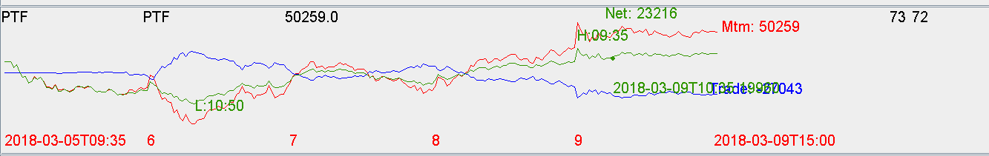

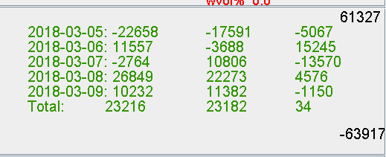

Fut trade pnl : +8k

Stock trade pnl: -35k

MTM: +60k

Net: +23k.

Why: liquidated some positions 1.17mm of delta on 3/5.

Brought delta from 2.8mm to 1.6mm.

Now delta is back to normal level (around 40%). Compared with 7mm (160%) during the most volatile periods, now is considerably lower.

Always keep under half position for the long term overnight.